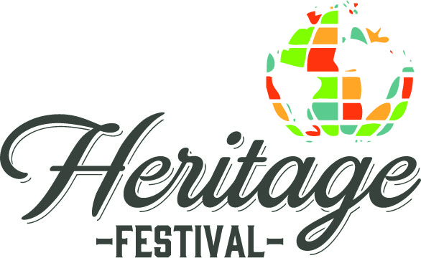
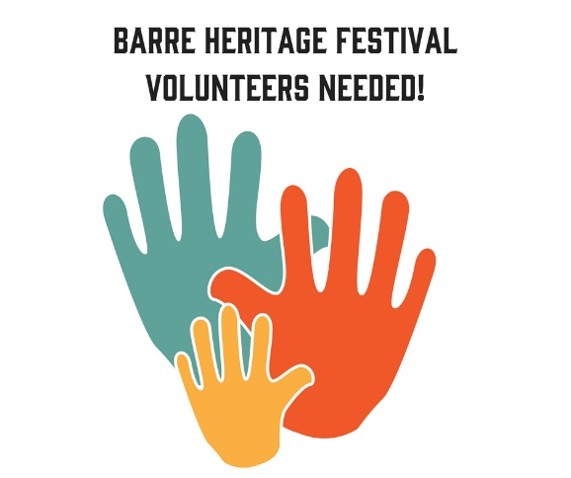

Volunteer Sign-up Form
Hello!
Thank you for offering your time to volunteer at the Barre Heritage Festival We really appreciate it, and wouldn't be able to do this without your help! This is a quick form just to grab some details from you, particularly your contact details and times available! We don't expect everyone to be available for the entire day - we want you to enjoy the Festival too! So, pick the time that works best for you! If you have any questions, please contact Tracie Lewis at 802-477-2967 or at: director@thebarrepartnership.com. Thank you!

Name *
Contact Email *
Contact Mobile Number *

Task Availability & Preferences
Below is a list of jobs we'll need help with. Please let us know what tasks you would prefer to do at the festival and we will try our best to make sure you're doing something you will have fun doing!

  - Friday 6pm – 7pm – Place A Frames Around Downtown
  - Friday 7pm – 10pm – Info Booth & Trash Pickup
  - Saturday 8am – 10am – Vendor Check in
  - Saturday 8am – 10am – Info Booth
  - Saturday 10am – 2pm – Info Booth
  - Saturday 2pm – 6pm – Info Booth
  - Saturday 6pm - 9pm – Info Booth
  - Saturday 9pm - 11pm – Info Booth

Please email sign up form to: director@thebarrepartnership.com when complete!

